**Basics of Programming Language**

**What is programming? Why do we need programming?**

Most of the activities we perform on day-to-day basis have lots of little steps. For e.g., an activity like send greeting card will contain small steps like go to the greeting card shop, choose it, pay for it, write the names and address, go to the post office, buy stamps, affix the stamps and drop the card in the post drop box.   
  
In this some steps like going to the post office, buying stamps and dropping the card in the post box are time-consuming and repetitive. Whereas calculating the price of all the cards we bought, paying the money to the shop-keeper and counting the change returned is error prone. These kinds of a step which does not need lot of human intervention and are not person dependent can be automated using Computer Programming. Please note that no matter how many steps we automate, there will be things like choosing the right card which needs the human intervention and the personal touch.

The Computer Programming help in automating the tasks which are time consuming, error prone, repetitive, not person dependent etc., They also help in stream lining the processes, provide better experience to the end users, keeping track of historical data, analyze the data etc., Some programs are very expensive and could take 5 or more years with multiple teams working on it, while some might be relatively easy and can be built in matter of weeks by an individual developer. One can improve their Programming Skills through Computer Programming.   
  
**Below are few examples of how computer programs changed the life in the last 15 years or so.**

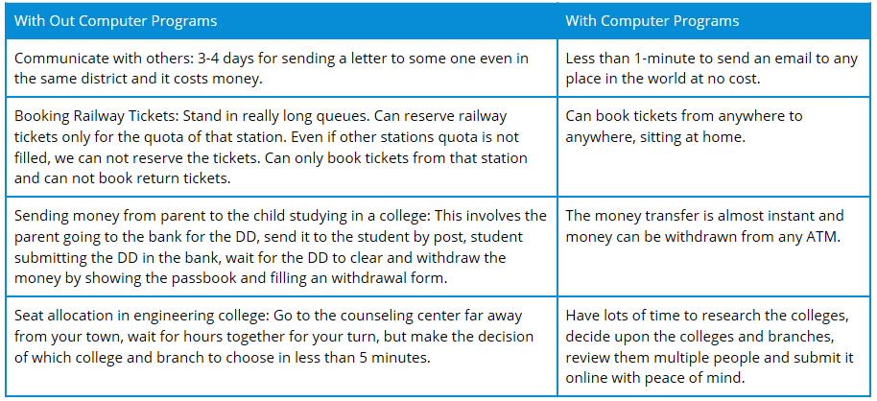

As explained at [Computer Programming](http://en.wikipedia.org/wiki/Computer_programming) is the process of designing, writing, testing, debugging, and maintaining the source code of computer programs. This source code is written in one or more programming languages (such as Java, C++, C#, Python, etc.). The purpose of programming is to create a set of instructions that computers use to perform specific operations or to exhibit desired behaviors. The process of writing source code often requires expertise in many different subjects, including knowledge of the application domain, specialized algorithms and formal logic.

**How to learn programming and programming skills:**

Every computer program needs to be written in one of the multiple computer languages which are available. One such programming language is Java.

**Please note the following points about Java**

* Before Java was invented there were other languages like COBOL, FORTRAN, C, C++, Small Talk etc., these languages had few disadvantages which were corrected in Java.
* Java is related to C++, which is a direct descendant of C. Java uses C syntax and many of the object oriented features are influenced by C++.
* As with every programming language, Java also innovated many new features to solve the fundamental problems which the previous languages could not solve.

Please note that the art of programming and the programming languages are different. As the environments change and as new problems arise, there will be new programming languages and new technologies which will be created. ***But the art of programming might not change so radically.*** As computer programmers or would-be programmers, it is really important to learn the programming skills along with languages. When we have strong programming skills, learning new languages or technologies will be far easier.   
  
**Please note the two important points about Programming Skills and Languages.**

* If a programmer is excellent in one language, he can naturally excel in any other language. Learning new technologies should be easy.
* Learning one language thoroughly is better than having limited knowledge in multiple languages.

**Programming Language**

A programming language is an artificial language used to express computations that can be performed with a machine particularly a computer.

## How to Become Excellent Programmer

**Listed below are few of skills which everyone needs for becoming a good programmer.**

* **Problem solving skills and aptitude:**

Every programmer must constantly strive to improve the problem solving skills. Since every program we write will be a new problem and without proper problem solving skills, we cannot effectively solve those problems. Aptitude is not just for clearing the rounds of job interview, but it is something which has to be practiced continuously even after getting the job. It is really important to keep them sharp throughout the programming career. There are good books like RS Agarwal for Aptitude and websites like indiabix which help in improving the problem solving skills and also keeping them sharp.

* **Ability to learn new things and be ready for change:**

With aptitude and problem solving skills comes the ability to learn new things. As you all know the world is changing fast, but programming languages and technologies change even faster. It is really important that we are willing to learn new technologies and methodologies and improve upon our existing capabilities to become an excellent programmer. If the real-time problems demand, it is necessary to quickly learn the new technologies and use them effectively to solve those problems. Also note that every new technology will not solve all the problems and be cautious while choosing whether the technology is suitable for your needs or problems.

* **Keyboard Typing skills:**

In the initial days of programming, please focus also on improving your keyboard typing skills. Typing properly will really help in writing the programs faster and help in not losing or forgetting the ideas we just thought. Typing skills once learned wrongly or improperly, will make it even more difficult to correct it later. So it is better to learn typing properly in the initial days. There are many good tools and websites online which help in improving the typing skills or even more better would be to go to proper typing institute at your location, Typing skills help you to become a good programmer.

**Types of Programming Language:**

**There are 3 types of Programming Language are there:**

1. ***High level Language.***
2. ***Assembly level Language.***
3. ***Machine level Language.***
4. **High level Language**

A High level language is machine-independent language, which uses familiar English language like syntax.

* It is more like human language and less like machine language.
* However, for a computer to understand and run a program created with a high-level language, it must be compiled into machine language.
* HLL allows programmers to concentrate on application development without bothering with the underlying machine architecture.
* HLL programs are also called as **SOURCE CODE.**

**Examples**

[BASIC](http://www.computerhope.com/jargon/b/basic.htm), [C](http://www.computerhope.com/jargon/c/c.htm), [C++](http://www.computerhope.com/jargon/c/cplus.htm), [Cobol](http://www.computerhope.com/jargon/c/cobol.htm), [FORTRAN](http://www.computerhope.com/jargon/f/fortran.htm), [Java](http://www.computerhope.com/jargon/j/java.htm), [Pascal](http://www.computerhope.com/jargon/p/pascal.htm), [Perl](http://www.computerhope.com/jargon/p/perl.htm), [PHP](http://www.computerhope.com/jargon/p/php.htm), [Python](http://www.computerhope.com/jargon/p/python.htm), [Ruby](http://www.computerhope.com/jargon/r/ruby.htm), and [Visual Basic](http://www.computerhope.com/jargon/v/vb.htm).

1. **Assembly Language**

Assembly Language is intermediate level programming language which is higher (is easier to use, but runs slower) than machine language and lower (is more difficult to use but runs faster) than a high level language such as BASIC, FORTRON, C, C++ or JAVA.

Programs written in assembly language are converted into machine language by specialized program called **assemblers or compilers** for their execution by the computer.

**Examples:**  
ADD for addition, SUB for subtraction etc.

1. **Machine Language**

Machine Language is a programming language that can be directly understood by the machine (computer) without conversion.

This language is different for each type of CPU, it is the native binary language (comprised of only two characters i.e.0 and 1) of the computer and is difficult to be read and understood by the humans.

Machine language programming is also called as **“*OBJECT CODE*”**.

**Limitations Of Machine Language:**

* It is very tedious and error prone process of writing programs in machine languages.
* High level Language programs are converted/ translated into machine level language by an assembler, compiler or interpreter.

[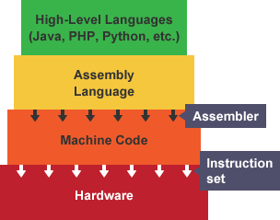](http://www.google.com/url?sa=i&rct=j&q=&esrc=s&source=images&cd=&cad=rja&uact=8&ved=0CAcQjRxqFQoTCOvE8p3yzscCFQmUDQodjmsIDQ&url=http://www.bbc.co.uk/education/guides/zgmpr82/revision/2&ei=_fXhVavSA4moNo7XoWg&psig=AFQjCNH0kf9DW5al2SRp8MQOfrUnGe1eQw&ust=1440956594908682)

# Low-level language

A **low-level language** is a [programming language](http://www.computerhope.com/jargon/p/proglang.htm) that provides little or no abstraction of programming concepts, and is very close to writing actual machine [instructions](http://www.computerhope.com/jargon/c/compinst.htm).

**Two good examples of low-level languages are:**

[Assembly](http://www.computerhope.com/jargon/a/al.htm) code and

[Machine code](http://www.computerhope.com/jargon/m/machlang.htm)

**Here's a list of programming languages ranging from very low to very high level:**

* [Machine Code](http://en.wikipedia.org/wiki/Machine_code) could probably be considered the lowest level programming language.
* [Assembly language](http://en.wikipedia.org/wiki/Assembly_language) is at the level of telling the processor what to do. There is still a conversion step towards machine code.
* [C](http://en.wikipedia.org/wiki/C_programming) is a step up from assembler, because you get to specify what you want to do in slightly more abstract terms, but you're still fairly close to the metal.
* [C++](http://en.wikipedia.org/wiki/C%2B%2B) does everything that C can do but adds the capability to abstract things away into classes.
* [Java](http://en.wikipedia.org/wiki/Java_(programming_language))/[C#](http://en.wikipedia.org/wiki/C_Sharp_(programming_language)) does similar things to C++ in a way, but without the opportunity to do everything you can do in C (like pointer manipulation in Java's case [thanks Joe!]). They have garbage collection though, which you have to do manually in C++.
* [Python](http://en.wikipedia.org/wiki/Python_(programming_language))/[Ruby](http://en.wikipedia.org/wiki/Ruby_(programming_language)) is even higher level, and let you forget about a lot of the details that you would need to specify in something like Java or C#.
* [SQL](http://en.wikipedia.org/wiki/Sql) is even higher level (it's declarative). Just say "Give me all the items in the table sorted by age" and it will work out the most efficient way to carry this out for you.

**Lowest level:**

Assembly language of the platform

**Low-level languages with higher-level flow control than assembly:**

* C, C++
* Pascal

**High-level languages:**

* FORTRAN
* COBOL
* Python
* Perl

**Highest-level languages:**

* PROLOG
* Python
* Scheme

[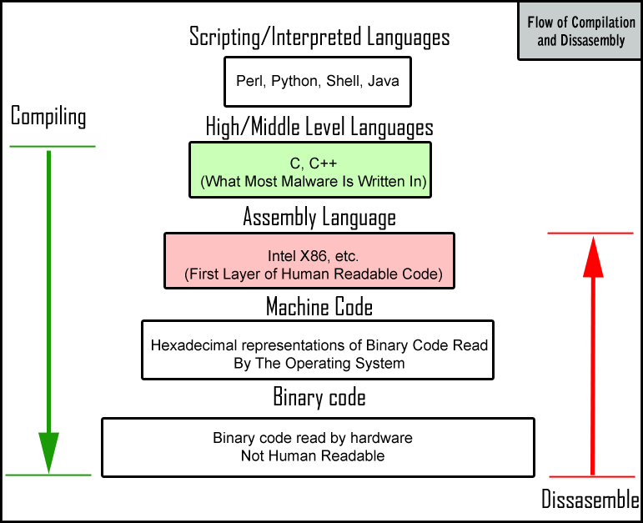](https://www.google.com/url?sa=i&rct=j&q=&esrc=s&source=images&cd=&cad=rja&uact=8&ved=0CAcQjRxqFQoTCMH9mLPGj8cCFUUpiAodTQAEOg&url=https://blog.malwarebytes.org/intelligence/2012/09/so-you-want-to-be-a-malware-analyst/&ei=T8DAVYGaA8XSoATNgJDQAw&bvm=bv.99261572,d.cGU&psig=AFQjCNEwV1m9Z84eOYp6wF6T4bD-y_tZiw&ust=1438781310147143)

### *Assembler, Compiler, Interpreter, Linker, Loader*

**Assembler:**

A computer will not understand any program written in a language, other than its machine language. The programs written in other languages must be translated into the machine language. Such translation is performed with the help of software.

**A program which translates an assembly language program into a machine language program is called an assembler.**

**Note:**

**Self-assembler Vs Cross Assembler:**

If an assembler which runs on a computer and produces the machine codes for the same computer then it is called **self-assembler or resident assembler**.

If an assembler that runs on a computer and produces the machine codes for other computer then it is called **Cross Assembler**.

**Assemblers are further divided into two types:**

**a**. One Pass Assembler and

**b**. Two Pass Assembler

One pass assembler is the assembler which assigns the memory addresses to the variables and translates the source code into machine code in the first pass simultaneously.

A Two Pass Assembler is the assembler which reads the source code twice. In the first pass, it reads all the variables and assigns them memory addresses. In the second pass, it reads the source code and translates the code into object code.

**Compiler:**

**Compile** is the process of creating an [executable](http://www.computerhope.com/jargon/e/execfile.htm) program from code written in a **compiled programming language.**

**It is a program which translates a high level language program into a machine language program.**

**A compiler is more intelligent than an assembler. It checks all kinds of limits, ranges, errors etc. But its program run time is more and **occupies a larger part of the memory**. It has **slow speed**. Because a compiler goes through the entire program and then translates the entire program into machine codes. **

**Self-compiler Vs Cross compiler**:

If a compiler runs on a computer and produces the machine codes for the same computer then it is known as a **self-compiler** or **resident compiler**.

On the other hand, if a compiler runs on a computer and produces the machine codes for other computer then it is known as a **cross compiler**.

**Note**: **The first compiler was developed by** [**Grace Hopper**](http://www.computerhope.com/people/grace_hopper.htm) while working on the Harvard Mark I computer. Today, most [high-level languages](http://www.computerhope.com/jargon/h/highll.htm) will include their own compiler or have toolkits available that can be used to compile the program. A good example of a **compiler used with** [**Java**](http://www.computerhope.com/jargon/j/java.htm) **is** [**Eclipse**](http://www.computerhope.com/jargon/e/eclipse.htm) and an example of a **compiler used with** [**C**](http://www.computerhope.com/jargon/c/c.htm) **and** [**C++**](http://www.computerhope.com/jargon/c/cplus.htm) **is the** [**gcc command**](http://www.computerhope.com/jargon/g/gcc.htm).

Depending on how big the program is it should take a few seconds or minutes to compile and if no errors are encountered while being compiled an executable file is created.  
*Tip: **Scripting languages like** [**Perl**](http://www.computerhope.com/jargon/p/perl.htm) **and** [**PHP**](http://www.computerhope.com/jargon/p/php.htm) **do not need to be compiled.**

[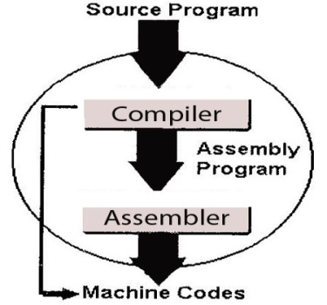](http://www.google.com/url?sa=i&rct=j&q=&esrc=s&source=images&cd=&cad=rja&uact=8&ved=0CAcQjRxqFQoTCNTX1ubxzscCFQHNgAodc9IKvg&url=http://www.sciencehq.com/computing-technology/compiler-construction.html&ei=ifXhVZTvD4GagwTzpKvwCw&psig=AFQjCNH0kf9DW5al2SRp8MQOfrUnGe1eQw&ust=1440956594908682)

**Interpreter:**

**An interpreter is a program which translates statements of a program into machine code. It translates only one statement of the program at a time.**

**Compiler Vs Interpreter:**

**Interpreter reads only one statement of program, translates it** and executes it**.** Then it reads the next statement of the program again translates it and executes it. In this way it proceeds further till all the statements are translated and executed.

On the other hand, a **compiler goes through the entire program** and then translates the entire program into machine codes.

* **A compiler is 5 to 25 times faster than an interpreter.**
* By the compiler, the machine codes are saved permanently for future reference. On the other hand, the machine codes produced by interpreter are not saved.
* An interpreter is a small program as compared to compiler. It occupies less memory space, so it can be used in a smaller system which has limited memory space.

**Linker:**

In high level languages, some built-in header files or libraries are stored. These libraries are predefined and these contain basic functions which are essential for executing the program. **These functions are linked to the libraries by a program called Linker.**

If linker does not find a library of a function then it informs to compiler and then compiler generates an error. **“The compiler automatically invokes the linker as the last step in compiling a program”.**

Not built in libraries, it also links the user defined functions to the user defined libraries. Usually a longer program is divided into smaller subprograms called **modules**. And these modules must be combined to execute the program. **The process of combining the modules is done by the linker.**

**Loader:**

**Loader is a program that loads machine codes of a program into the system memory.**

In Computing, a **loader** is the part of an Operating System that is responsible for loading programs. It is one of the essential stages in the process of starting a program. Because it places programs into memory and prepares them for execution.

**Loading a program involves reading the contents of executable file into memory.**  Once loading is complete, the operating system starts the program by passing control to the loaded program code.

All operating systems that support program loading have loaders.

In many operating systems the loader is permanently resident in memory.

[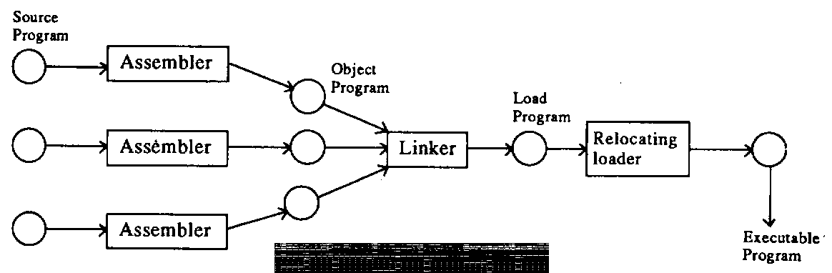](http://www.google.com/url?sa=i&rct=j&q=&esrc=s&source=images&cd=&cad=rja&uact=8&ved=0CAcQjRxqFQoTCNnNuf7xzscCFQ2sgAodOtcJHw&url=http://www.icse.s5.com/notes/m2.html&ei=u_XhVZmEB43YggS6rqf4AQ&psig=AFQjCNH0kf9DW5al2SRp8MQOfrUnGe1eQw&ust=1440956594908682)

**Java Compiler:**

A **Java compiler** is a [compiler](https://en.wikipedia.org/wiki/Compiler) for the programming language [Java](https://en.wikipedia.org/wiki/Java_(programming_language)). The most common form of output from a Java compiler is [Java class files](https://en.wikipedia.org/wiki/Java_class_file) containing **“Platform-Neutral** [**Java Bytecode**](https://en.wikipedia.org/wiki/Java_bytecode)**”.**

The [Java virtual machine](https://en.wikipedia.org/wiki/Java_virtual_machine) (JVM) loads the class files and either [**interprets**](https://en.wikipedia.org/wiki/Interpreter_(computing)) **the** [**bytecode**](https://en.wikipedia.org/wiki/Bytecode) **or** [**just-in-time**](https://en.wikipedia.org/wiki/Just-in-time_compilation) **compiles it to** [**machine code**](https://en.wikipedia.org/wiki/Machine_code) and then possibly optimizes it using [dynamic compilation](https://en.wikipedia.org/wiki/Dynamic_compilation).

A standard on how to interact with Java compilers programmatically was specified in [JSR](https://en.wikipedia.org/wiki/Java_Community_Process) (Java Specification Requests) 199.

**Major Java Compilers:**

* The Java Programming Language Compiler ([**javac**](https://en.wikipedia.org/wiki/Javac)), included in the [Java Development Kit](https://en.wikipedia.org/wiki/Java_Development_Kit) from [Oracle Corporation](https://en.wikipedia.org/wiki/Oracle_Corporation), open-sourced since 13 November 2006.
* [GNU Compiler for Java](https://en.wikipedia.org/wiki/GNU_Compiler_for_Java) (**GCJ**), a part of the [GNU Compiler Collection](https://en.wikipedia.org/wiki/GNU_Compiler_Collection), which compiles [C](https://en.wikipedia.org/wiki/C_(programming_language)), [C++](https://en.wikipedia.org/wiki/C%2B%2B), [Fortran](https://en.wikipedia.org/wiki/Fortran), [Pascal](https://en.wikipedia.org/wiki/Pascal_(programming_language)) and other [programming languages](https://en.wikipedia.org/wiki/Programming_language) besides Java. It can also generate [native code](https://en.wikipedia.org/wiki/Native_code) using the back-end of GCC.
* Eclipse Compiler for Java (**ECJ**), an open source [incremental compiler](https://en.wikipedia.org/wiki/Incremental_compiler) used by the [Eclipse](https://en.wikipedia.org/wiki/Eclipse_(software)) project.

**Note:**  
  
An incremental compiler is one that can recompile only those portions of a program that have been modified. Ordinary compilers must process entire modules or programs.

**Platform:**  
Operating system and architecture of the processor together is known as ‘**Platform’**.

**Source Code:**  
Code means a group of statements.   
The group of statements present in the high-level format which looks like English is known as **Source Code.**The syntax of source code changes from programming language to programming language. **Executable code:**  
The group of statements which are present in the low-level format (in machine language) which looks like the stream of 0’s and 1’s is known as ‘**Executable Code**’.  
  
The format of executable code changes operating system to operating system. Thus the executable code is always specific to the operating systems.  
The executable code generated for one O.S. couldn’t be understood by the processor which is working under a different operating system.

**Format:**  
The way how we represent the data is known as format.  
**Or**The process what we follow for representing the data is known as format.

**Platform Dependency and platform Independency (In General):**

Anything specific to the operating system is always platform dependent. Since the executable code is specific to the OS, the executable code is always platform dependent.

Anything which is not specific to the OS would be known as platform Independent. Since the source code is not specific to the OS. So, it is always platform independent.

**Compiled Code:**  
Any group of statements what we get after the compilation can be called as compiled code. **Platform Dependency and Platform Independency**

If the compiled code of the program can be executed irrespective of the OS under which it has been compiled, then we call that program and its programming language as **Platform Independent**.

If the compiled code of a program couldn’t be executed irrespective of the OS under which it has been compiled, then that program and its programming language is known as **Platform Dependent**.

**Example:**  
Since the compiled code of a C-program which is also the executable code, couldn’t be executed irrespective of the OS under which it has been compiled, C is a platform dependent.  
 **Note:**

Internet is the root cause for the development of platform Independency concept.

**Internet:**  
It is network of networks.

**Using internet we can do only 2 things:**a) Sending the data.  
b) Receiving the data.

Transferring the data

Internet🡪 Culture/Practice of sharing of programs and data 🡪 Need for platform Independency🡪 OAK (first developed platform Independent language, developed by James Gosling)🡪 Features for business oriented applications were added i.e. JAVA (developed by SUN corporation i.e. Group of people including Gosling).

**Byte Code:**  
It is the compiled code of a Java program.

**Code means a group of statements and Bytes is the name of that format.**  
  
The group of statements present in the middle level format representing high level java statements using Byte format is known as the Byte code.

Since the byte code is the executable code, it wouldn’t be specific to any OS. Thus byte code is always platform independent.  
 **“The secret of platform independency in Java is Byte code”.  
  
Static Loading:**

The concept of allocating the memory (in the RAM) and loading the functionalities to the RAM before the program is under execution or before the function call is made is known as **Static Loading**.

Static loading increases overhead on the operating system.  
  
All the structured programming language programs would be always working based on the concept of the Static loading.

**Example:** C programming

**Dynamic Loading:**  
The process of allocating the memory space (in the RAM) and loading the functionalities to the RAM at the run time, when the program is under execution, dynamically as and when a function call is made is known as **Dynamic Loading**.  
  
Always Dynamic Loading would be advantageous.

All the Object Oriented programming Language programs like Java would be working based on the concept of Dynamic Loading.

**Software Vs Hardware:**

Computer hardware is any physical device used in or with your machine, whereas software is a collection of [code](http://www.computerhope.com/jargon/c/code.htm) installed onto your computer's hard drive.

**Example:**   
The computer [monitor](http://www.computerhope.com/jargon/m/monitor.htm) you are using to read this text and the [mouse](http://www.computerhope.com/jargon/m/mouse.htm) you are using to navigate this web page is computer hardware. The [Internet browser](http://www.computerhope.com/jargon/b/browser.htm) that allowed you to visit this page and the [operating system](http://www.computerhope.com/jargon/o/os.htm) that the browser is running on is considered software.

**Types Of Software**

According to industry standards, we have three types of software. They are:

1. ***System Software***
2. ***Application Software and***
3. ***Internet Software.***
4. **System Software:**

**The basic aims of system software are:**

1. Development of functionality of hardware devices.
2. Development of language compilers and interpreters.
3. Development of RTOS (Real Time Operating Systems).

Most of CMM-5 level companies use the following languages for development of system software.

* C and
* ALP [Assembly Language Programming]

In general, any kind of program which is running in the background to support foreground programs, these background programs are known as **System Level Programs**, foreground programs are known as **User level applications**.

1. **Application Software:**

The aim of application software is to develop information system (i.e. the process of converting of manual work of the organization into automated work or electronic work).

**Some of the organizations where we can develop the application software are:**

1. Financial Sector (Banks, LICs, Auditing Companies, etc.).
2. Health Care Sector (Hospitals, Diagnostic centers, etc.).
3. Transportation sectors (Bus Reservation systems, Train reservation system, Airlines).
4. Super Market etc.

In general, if we are able to develop a project for the organization then that project comes under applications software.

**To develop application software, we need two types of technologies:**

1. **Frontend /GUI /Windows Technologies:**

Developer 2000 – Oracle Corporation

Visual Basic – Microsoft

VB.Net – Microsoft

Awt/Applets/Swings – Sun Micro systems

When we develop any frontend application, I, II, III technologies, those applications run on Microsoft providing operating system only, but not on non-Microsoft operating system. These types of applications are known as **Platform dependent**.

When we develop any GUI app/Frontend application by using (**iv**) technologies, those applications runs on every operating system. So, that these applications are called “**Platform Independent**”.

As of today, most of the organizations prefer to develop platform independent applications.

1. **Backend Technologies (Data base products):**

Dbase, dbase III plus fox pro (outdated)

Industry Used

Oracle 10g – Oracle Corporation, SQL Server – MS, DB2 – IBM

MySQL – SUN, Sybase – Red hat, Paradox- IBM,  
Ingress – Ingress corporation, etc.

**Note:**   
**In order to store the data permanently, we have two approaches in information technology. They are:**

* Through files concept and
* Through data base concept.

Industries are not recommended to store the data permanently in the form of files because the data of the file can be manipulated by any unauthorized users and more-over files concept is not providing usernames and passwords.

**As a software engineer in the industry, we developed two types of applications. They are:**

* 1. **Standalone application and**
  2. **Distributed Application.**

A **standalone application** is one which is running in the context of local disk and whose results are not sharable.

**Example:** All the applications of system software and application software come under standalone applications.

**Distributed applications** are those which are running in the context of Browser/WWW and whose results are sharable across the globe.

**Example:** mail.yahoo.com, gmail.com etc.

In general, all the websites comes under distributed applications.

**Internet Software:**

The basic aim of internet software is to develop distributed applications.

To develop a distributed application, we are using the following languages/ technologies.

1. JAVA developed by SUN Microsystem INC, USA.
2. .NET developed by Microsoft INC, USA.

**Architecture required for development of Distributed applications:**

According to industry standards, distributed applications will be developed by well-known architecture called “**Client-Server Architecture**”.

**According to industry standards, client-server architecture has 3 categories. They are:**

1. **2-Tier Architecture:**

**It contains:**

* Set of Client programs
* Set of Server Programs

1. **3-Tier Architecture:**

**It contains:**

* Set of client programs.
* Set of Server programs.
* Set of Database software.

1. **n-Tier Architecture:**

**It contains:**

* Set of Client Programs
* Set of Firewall programs
* Set of Server Side Programs
* Set of database software.

**The following diagram gives the diagrammatic view of client-server architecture:**

Resource Pool

[**www.yahoo.com**](http://www.yahoo.com)[**www.gmail.com**](http://www.gmail.com) **www.google.com**

Fire  
Wall

Tier 1  
(View)

Tier-3 (Model)

Tier-2 (Controller)

Tier-n

Response

Request

Server Program

Client Program

**Client:**   
  
A client is the Java program which always makes a request to the server to get the services.

**Server:**   
  
A server is also a program which always recieves client request, process the client request and gives response back to clients concurrently.

The basic advantages of server software is to get **concurrent access.**

**The following table gives list of server names and their vendors:**

|  |  |
| --- | --- |
| **Server Software Name** | **Server Vendor Name** |
| **Tomcat** | Apache Jakartha S/W foundation |
| **Weblogic** | BEA corp |
| **WebSphere** | IBM |
| **Oracle 10g** | Oracle corp |
| **Pramathi** | Pramathi s/w services, Hyderabad |

Etc..

**Firewall:**

A firewall is the security program which will validate whether the client request is virus free or virus effected.

**Database Software:**

It is used to store the data permanently with high effective services.

In industry, all the database software are known as backend technology.

**Protocol:**

The set of rules, used for exchanging the data between client and server application is known as **protocol**.

In the industry all the internet applications are making use of http.

**Resource Pool:**

It is the place where the set of programs are residing in the context of server software.

**What are the differences between http and FTP?**

|  |  |
| --- | --- |
| **Http** | **FTP** |
| It is one of the TCP protocol. | It is one of the UDP protocol. |
| Http is one of the stateless protocols. | It is one of the state full protocols. |
| Http is one of the acknowledgement oriented protocol. | FTP is one of the non-acknowledgement oriented protocol. |

A **State less protocol** is one which maintains an identity of a client for a period of time.

**Example:** http

**A State full protocol** is one which maintains an identity of a client forever.

**Example:** FTP

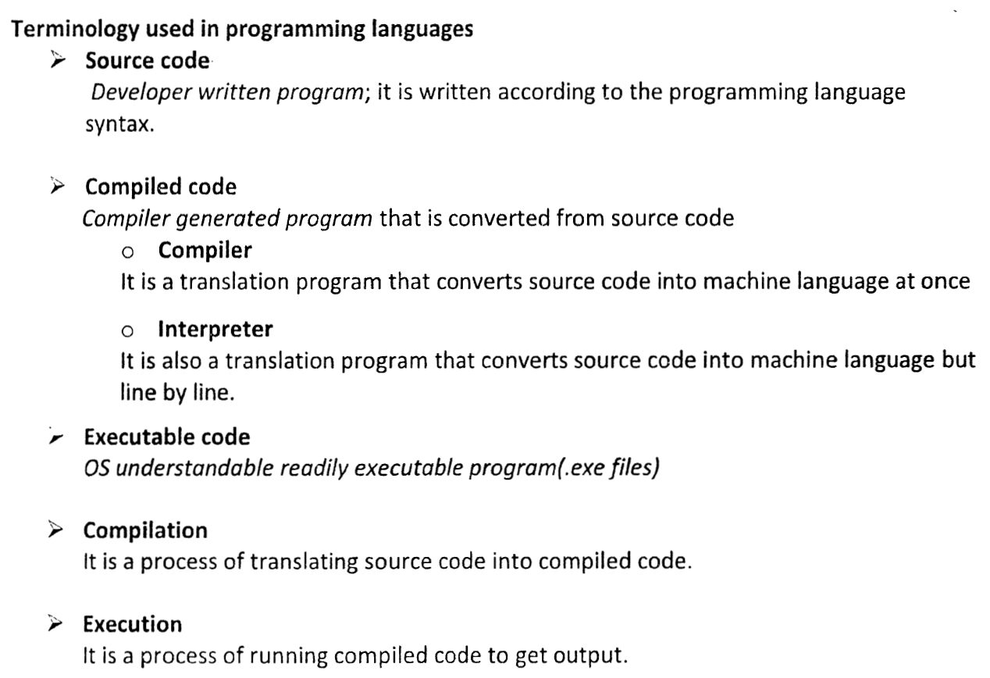

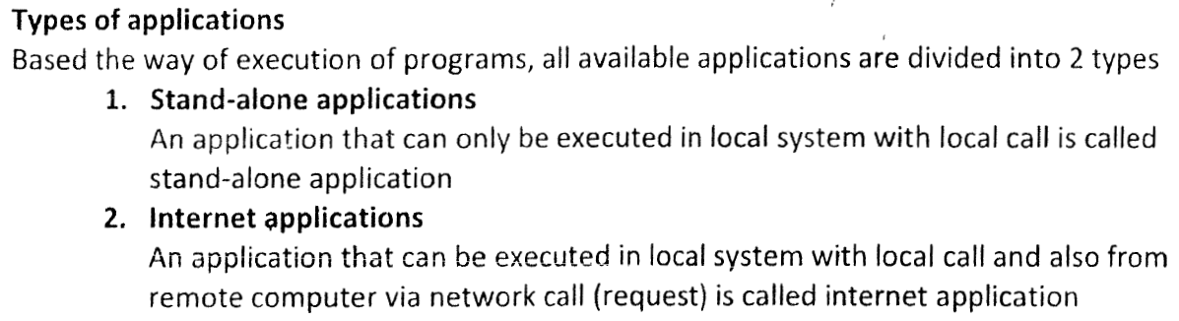

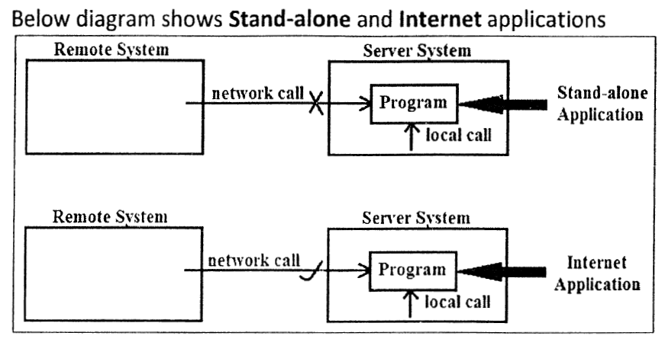

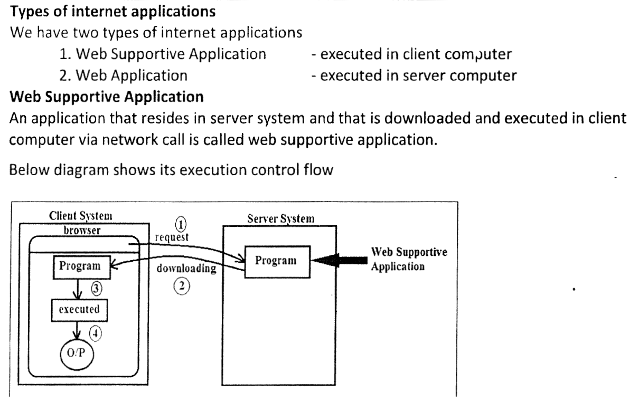

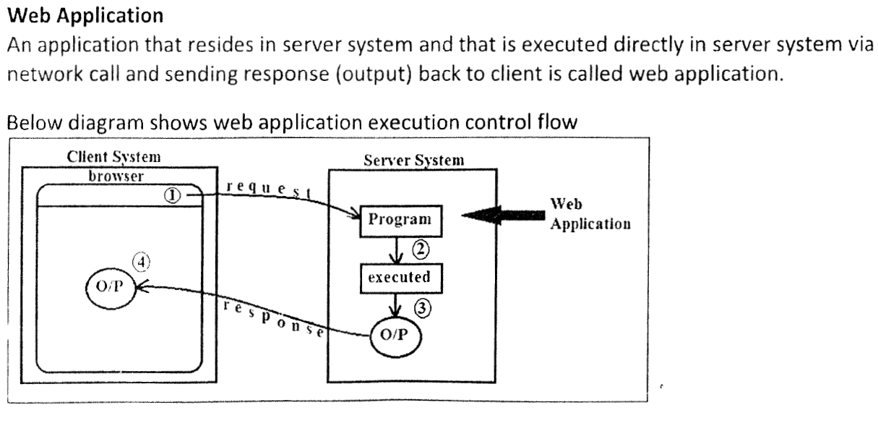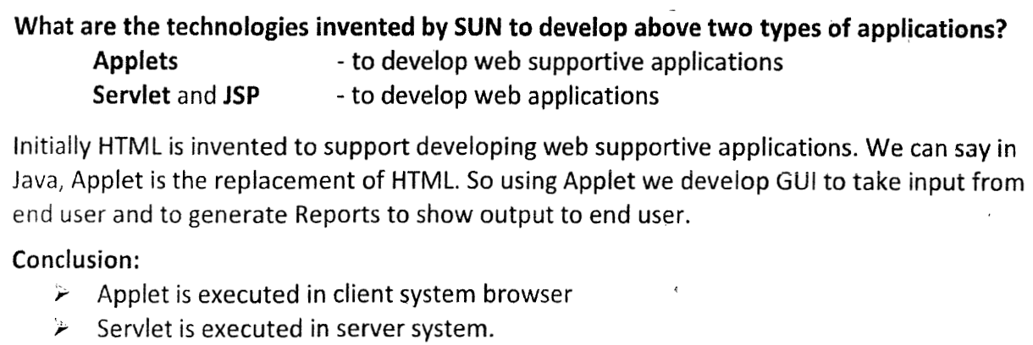

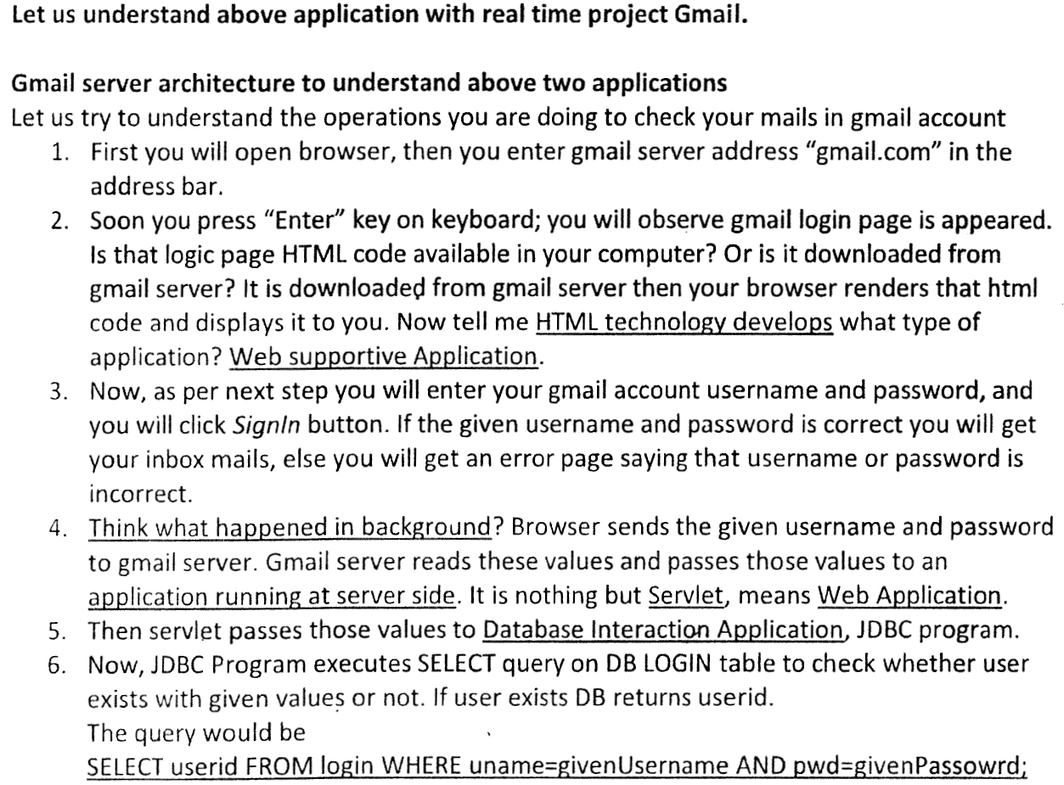

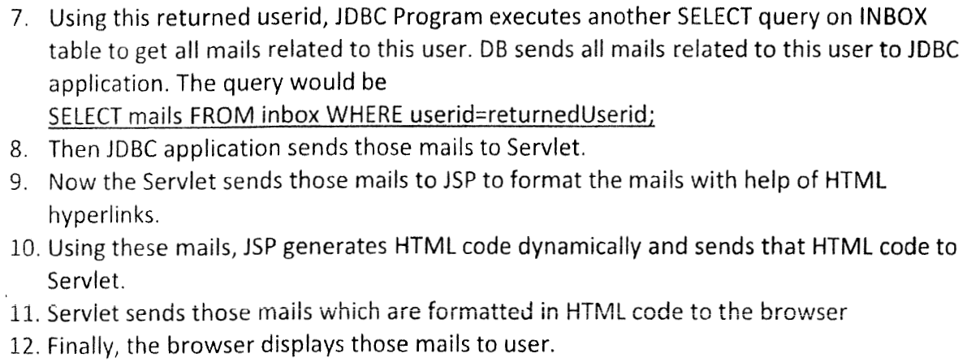

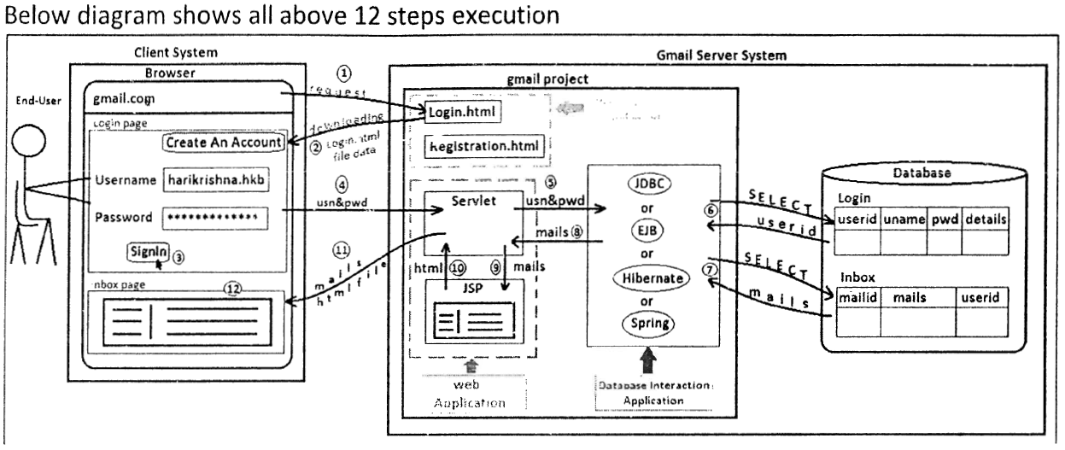

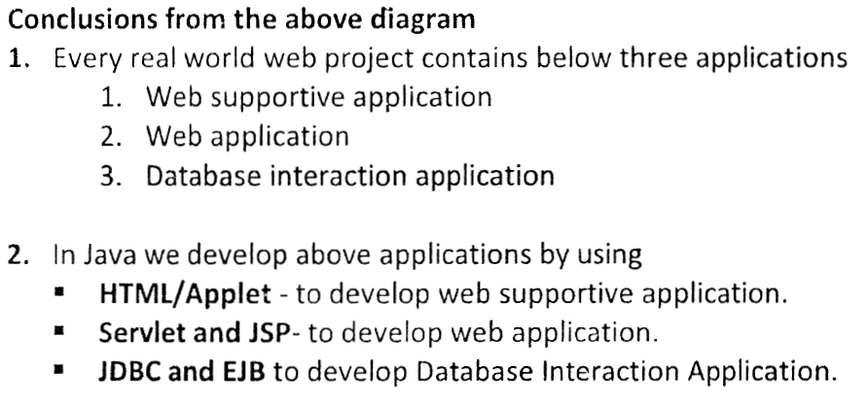

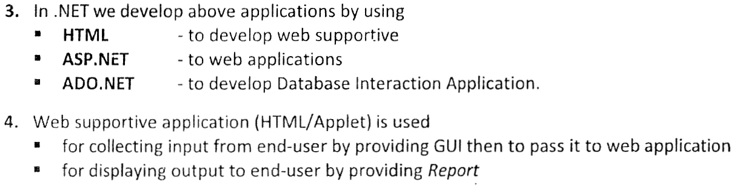

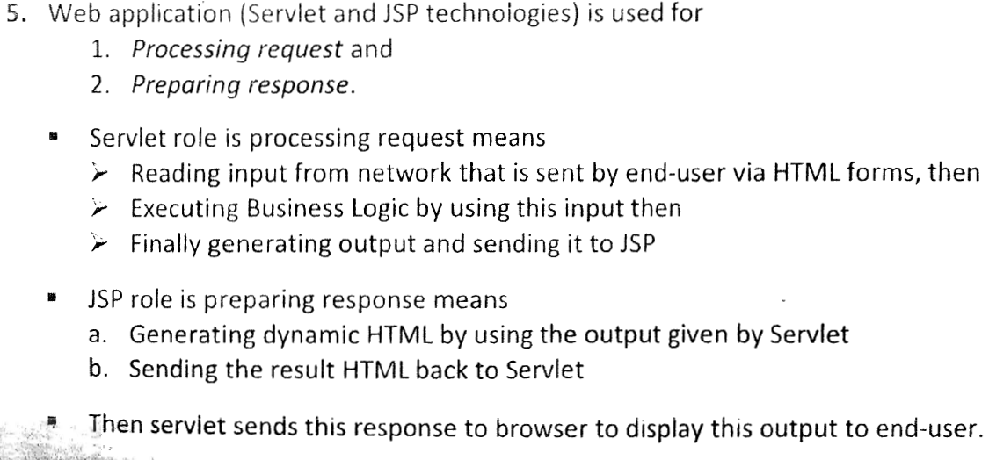

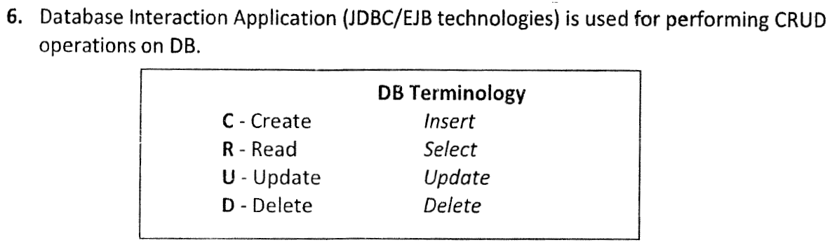

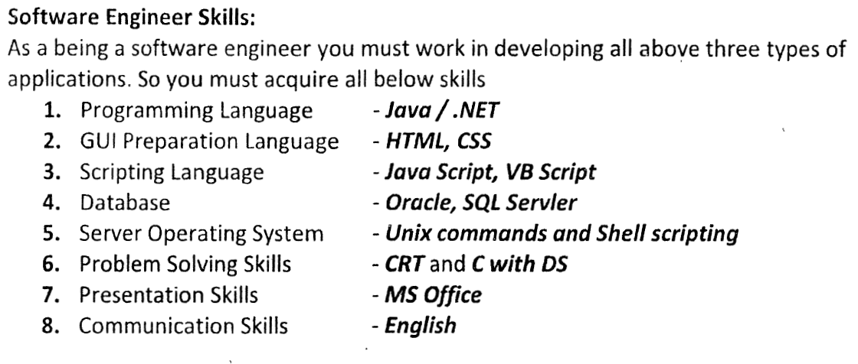

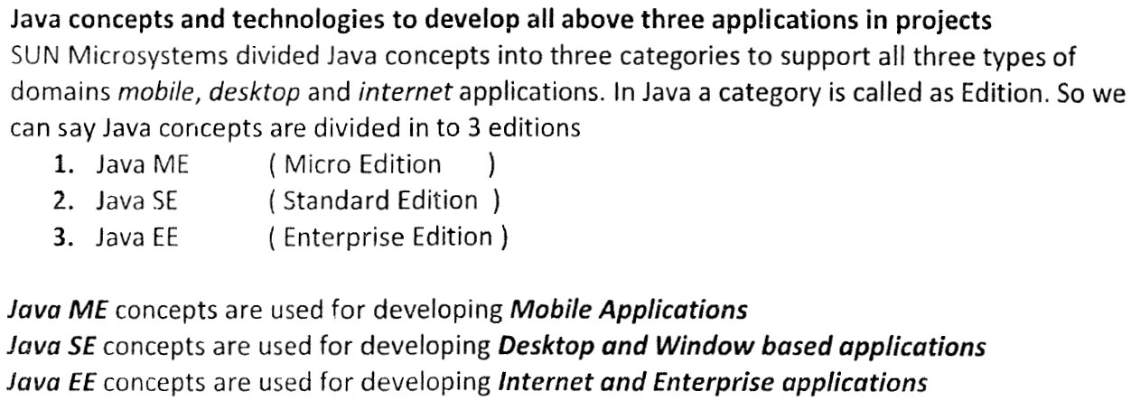





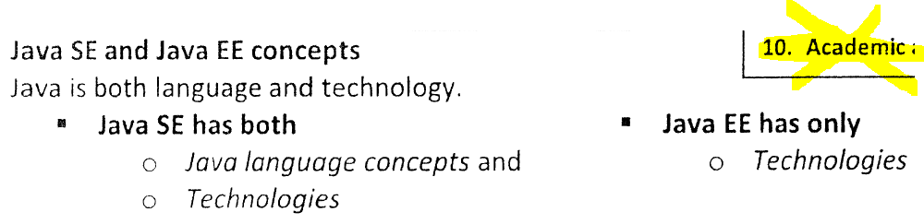

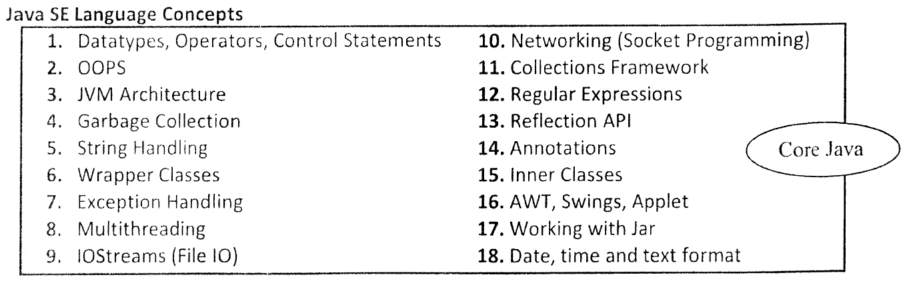

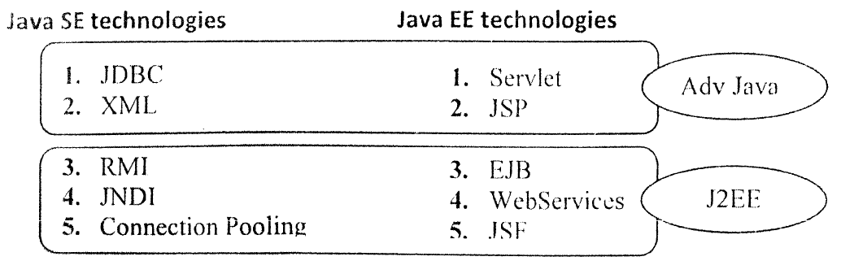

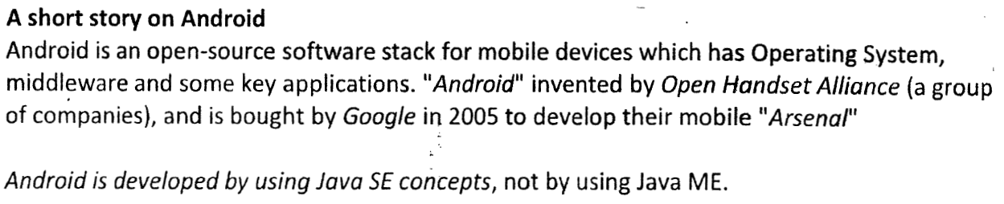

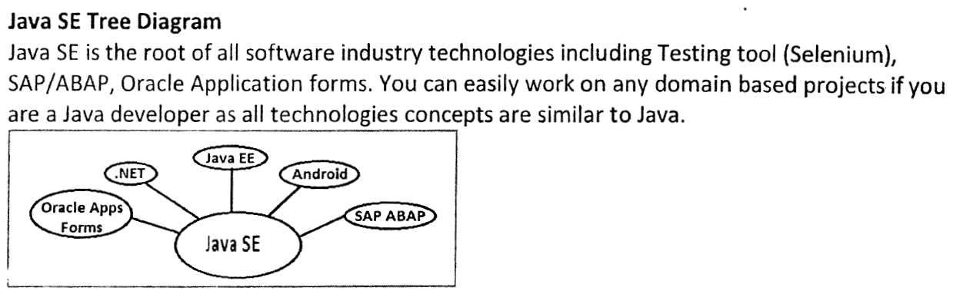

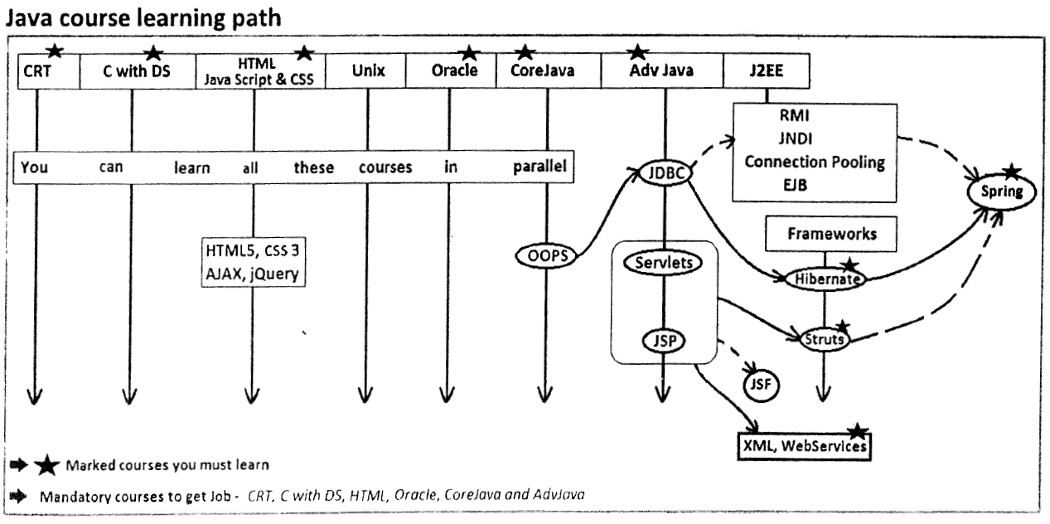









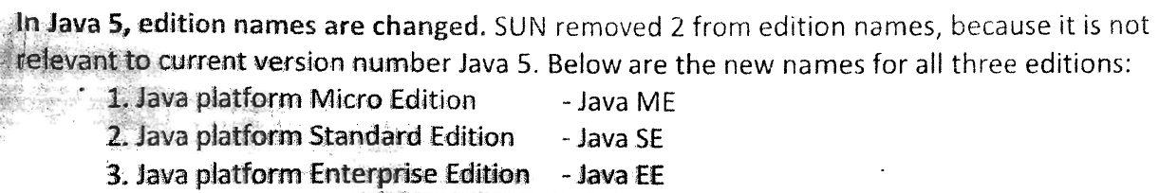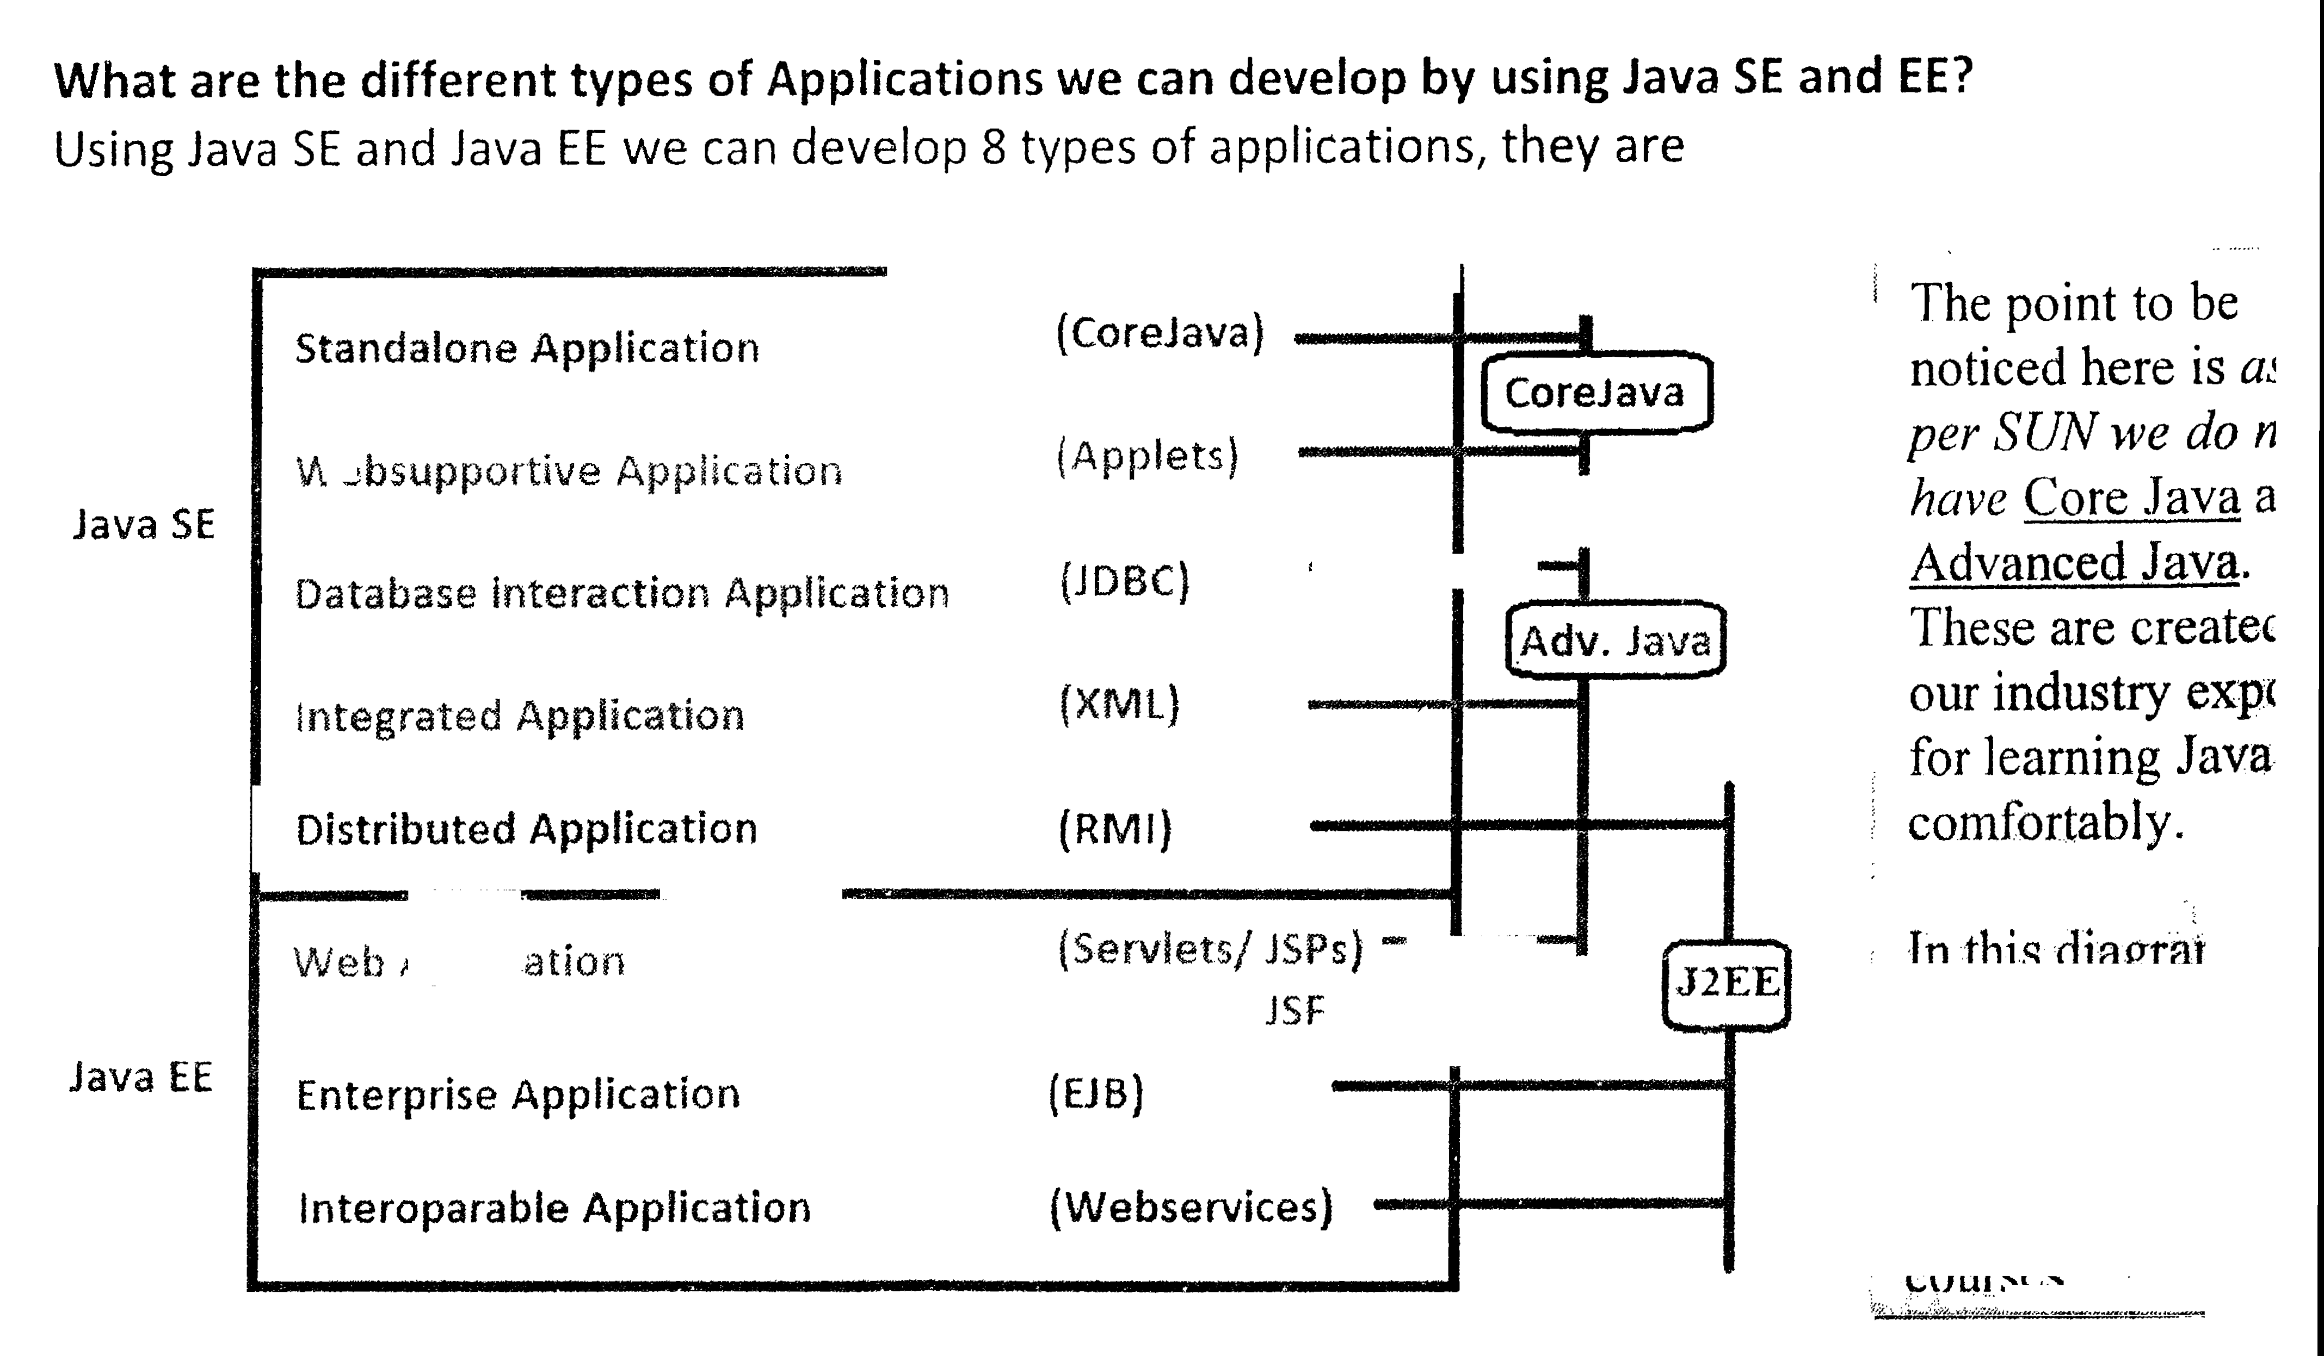

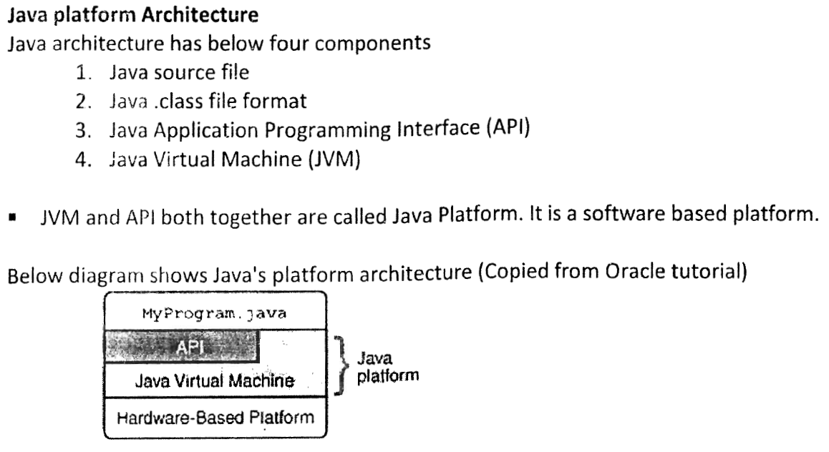

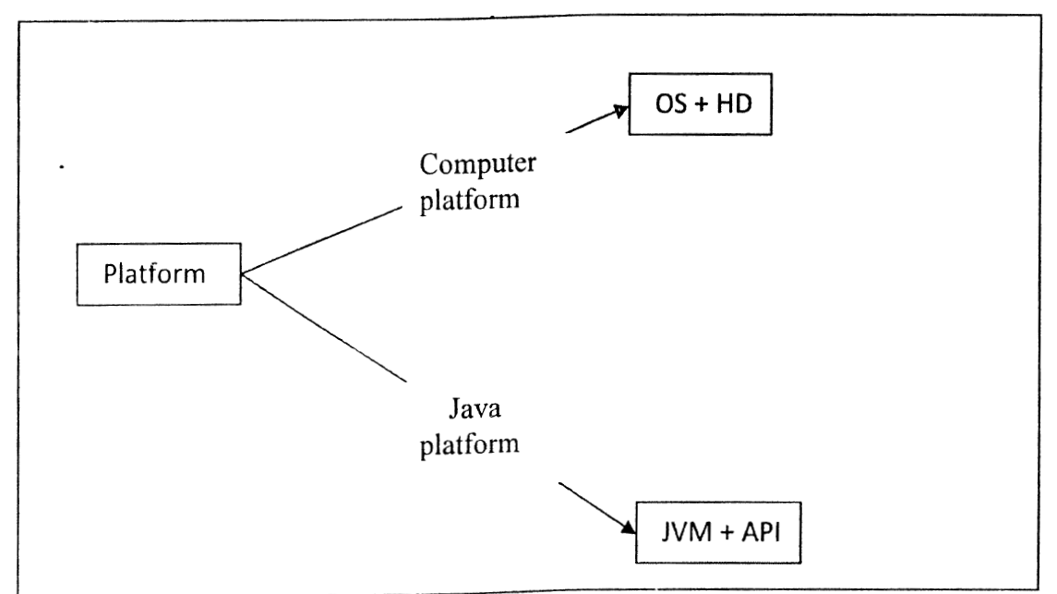

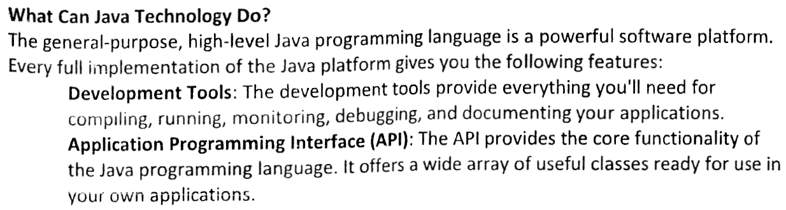

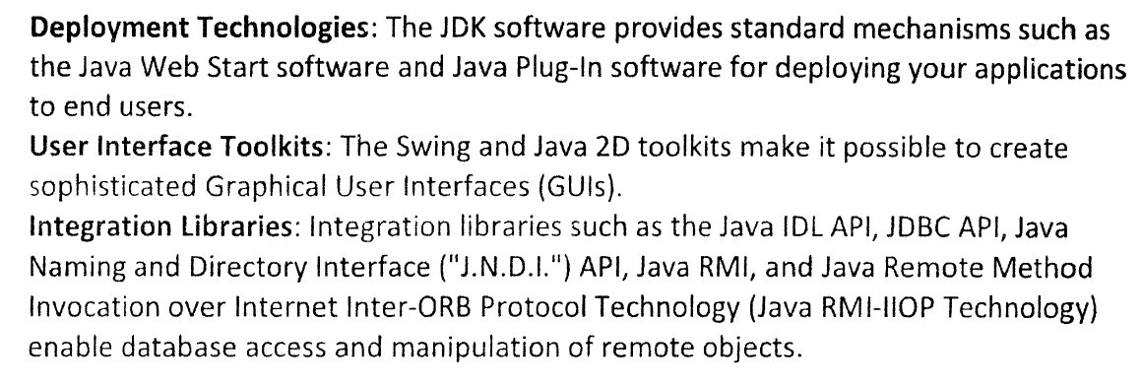

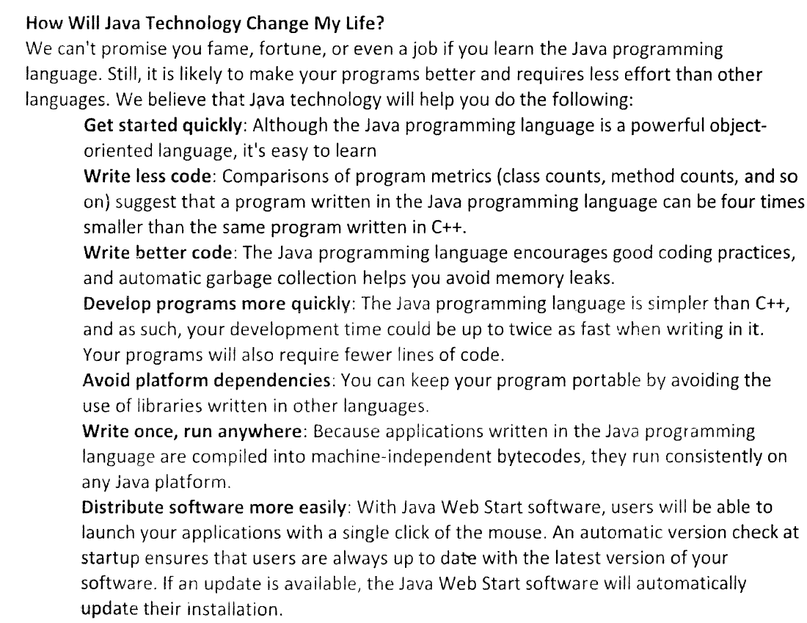

**Java and Internet – Creating Java Applet:**

Internet helped Java to bring it to the forefront and Java influenced Internet by simplifying the web programming and inventing applets. Applets expanded the scope of internet. Java also addressed two other important issues of internet, which are security and portability.

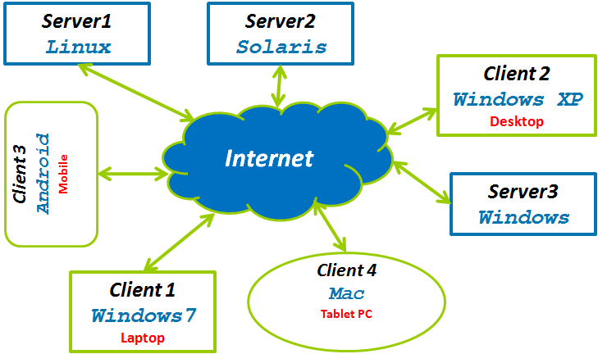

* **Java Applets** - An applet is a special kind of program that is transmitted over the Internet and automatically executed by the Java-compatible web browser. Applets are usually small programs and these helped in moving some user interactive programs from server to client, hence improving the usability of the web application. The typical examples of applets are tax calculator or some forms with input fields having lots of interaction between them.
* **Security** - Since applets are automatically downloaded and run on the client machine, there are restrictions on what can be done in Applets. They can use only a subset of all the functions supported by Java. e.g., They cannot access local file system or they cannot launch other programs on the client system. Java achieved this protection by restricting an applet to Java execution environment and not allowing it access to other parts of the computer.
* **Portability** - Since Internet is comprised of many different types of computers and operating systems, it is important for the programs to run on all these systems. Either we have to have a separate program for every operating system or write a portable (or platform independent) program like Java Applet which runs everywhere. This portability is achieved by using [Bytecode In Java](http://java.meritcampus.com/core-java-topics/Bytecode-In-Java)

**What is Servlet in Java?**

[Applets](http://java.meritcampus.com/core-java-topics/Java-And-Internet-Creating-Java-Applet) are just one half of any *client server system*. Java also has Servlets which are useful in dynamically extending the functionality of web browser. With Servlets, Java spanned on the both sides of *client server system*.

Servlets can be used to dynamically generate web content. The information stored in database tables can be retrieved and shown as a web page on a browser. Typically, this involves reading the database tables using *JDBC* and converting them into formatted *HTML* and sending it to the browser for display. For example, depending upon the user search request, the matching items from the catalog are shown along with the prices and their availability. Most of the web page is constructed dynamically and has details for a specific user search request.   
Servlets like all Java programs are portable and can run on any server that supports JVM and has a servlet container. e.g., they can run on *IBM WebSphere*, *Tomcat* or *Web Logic*.

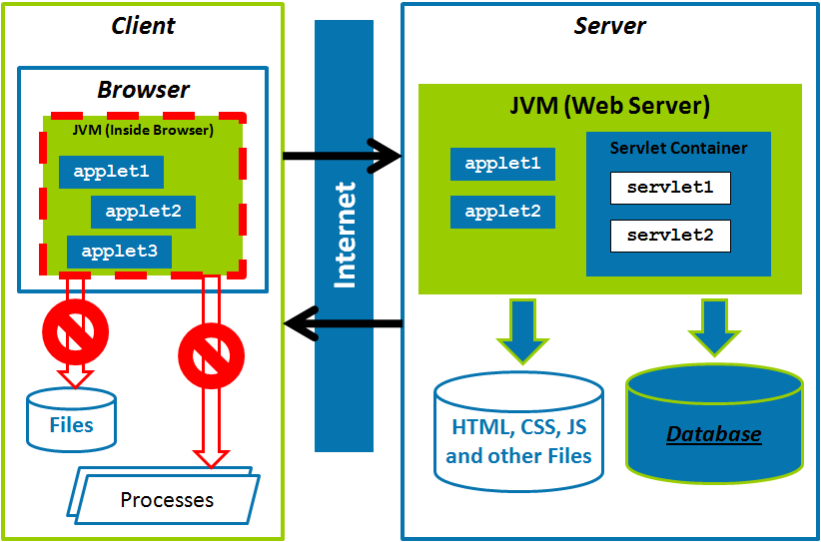

**Java Bytecode:**

Java in order to support [security](http://java.meritcampus.com/core-java-topics/Java-And-Internet-Creating-Java-Applet) and [portability](http://java.meritcampus.com/core-java-topics/Java-And-Internet-Creating-Java-Applet), does not compile the source code to executable code. It is translated into bytecode, which is highly optimized set of instructions designed to be executed by the Java run-time system, which is called Java Virtual Machine (JVM). JVM is an *interpreter* of bytecode.

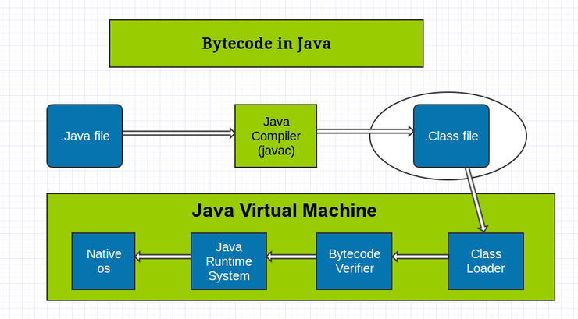

Converting the Java program to bytecode instead of compiled code, offers a great ability to run those programs on multiple platforms. Once we have the run-time package for a given system, then any Java program can run on it. Instead, if Java programs were to be compiled to the native code, then it would be very difficult since the same program has to be compiled for every CPU type.   
Using *JVM* also offers a protected environment which helps in enhanced safety for the system. This reduces any side effects caused by the programs.